Offensive Language Detection in Tweets
Automated detection of offensive content is essential for safer online spaces. This blog describes my approach to classifying tweets into Not Offensive (NOT), Targeted Insult (TIN), and Untargeted (UNT) categories.

1. Data and Preprocessing
The training set had 13,240 tweets with strong class imbalance. I applied the following preprocessing steps: - Lowercasing and removal of @user and url placeholders. - Snowball stemming (English) to normalise word forms. - Stopword removal to focus on content-bearing terms.

2. Feature Extraction
I used TF-IDF with sublinear_tf=True to dampen the effect of very frequent terms, and restricted the vocabulary to 8,000 unigrams. The 70/30 train–validation split used random_state=100 as specified.

3. Models and Results
Three classifiers were compared:
Model | Accuracy | Macro F1
Multinomial NB | 0.7243 | 0.4268
Gradient Boosting | 0.7470 | 0.4459
KNN | 0.6709 | 0.2865
Gradient Boosting achieved the highest Macro F1, which is important for the imbalanced UNT class. The ensemble of decision trees captured non-linear interactions in the sparse TF-IDF space better than the linear NB and the distance-based KNN.

4. Conclusion
Gradient Boosting was selected as the final model. It was trained on the full preprocessed corpus and used to predict labels for the 460 test tweets. The blog includes a link to the implementation.
Code Notebook
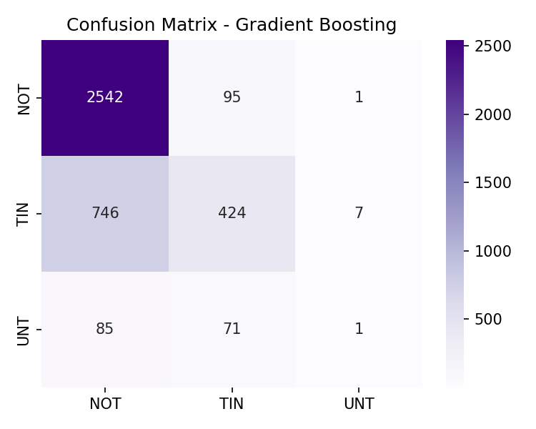
Confusion Matrix

